Fleetwood Cemetery History Trail

  - Wyre Council 2026

www.wyre.gov.uk
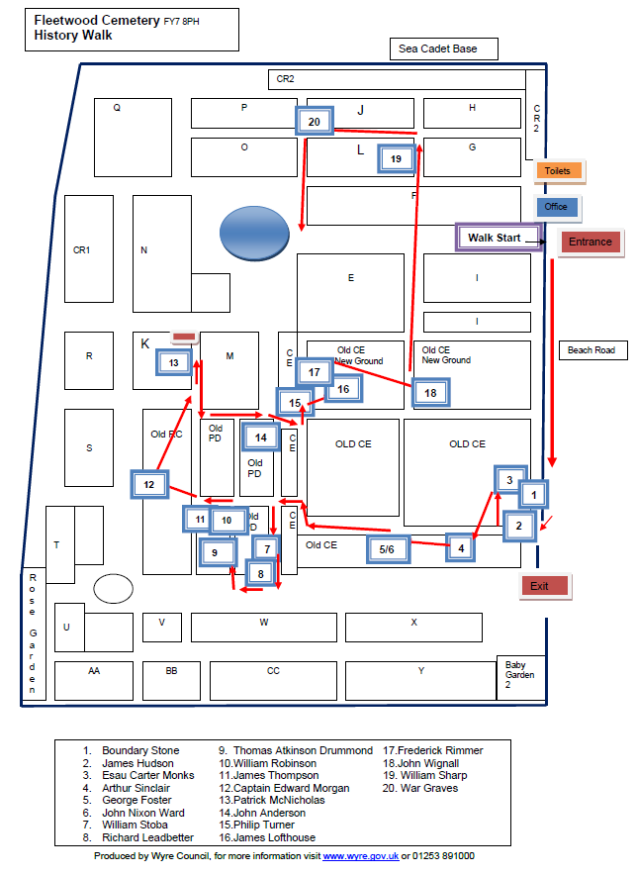

History of Fleetwood Cemetery
Fleetwood Cemetery is the oldest and largest cemetery managed by Wyre Council and situated on Beach Road, Fleetwood, Lancashire FY7 8PH.
The first known burial took place on 28th September 1841 of James Thompson. The cemetery was originally marked for Church of England, Roman Catholic and Non-Conformist denominations, but now also has areas for Baby Gardens of Remembrance, Cremated Remains interments and the new Columbariums covering a total area of 17.4 acres.
Fleetwood became an independent town in 1894 and was under the parish of St Peters. The cemetery was based away from the main town by Sir Peter Hesketh who also built the railway line to Fleetwood between 1835 and 1840.
There was originally two mortuary chapels built in the 1800’s for Church of England and the Non-Conformist Sections, with the main Roman Catholic church still present today built 28th August 1932, the first stone laid by the Right Reverent Thomas Wulston Pearson OSB, Bishop of Lancaster.
The two smaller chapels were still present on a 1963 map but were demolished between that date and 1974. Wyre Borough Council took over the maintenance and management of the cemeteries and chapels from the respective denominations.
Sadly, the records for the original Roman Catholic area were destroyed in a fire prior to transfer to the Borough and therefore we only have the inscribed records of memorials for this section.
The main gates and alternative entrance to the cemetery were built in 1920.
Wyre Council Cemeteries have recorded over 40,000 burials and approximately 11,000 memorials within the Fleetwood cemetery that are all tested on a 5-year programme.
The burial registers have now been scanned and are available at deceasedonline.com for assistance and other enquiries please contact Bereavement Services at www.wyre.gov.uk or 01253 891000.
We have produced this booklet to capture the history of the cemetery and hope that it provides an insight into the town’s historical past.
Donations received are being put towards restoration works within the cemetery.

GPS location N53 55’21.48 W3 2’13.34
Beach Road Fleetwood Lancashire FY7 8PS

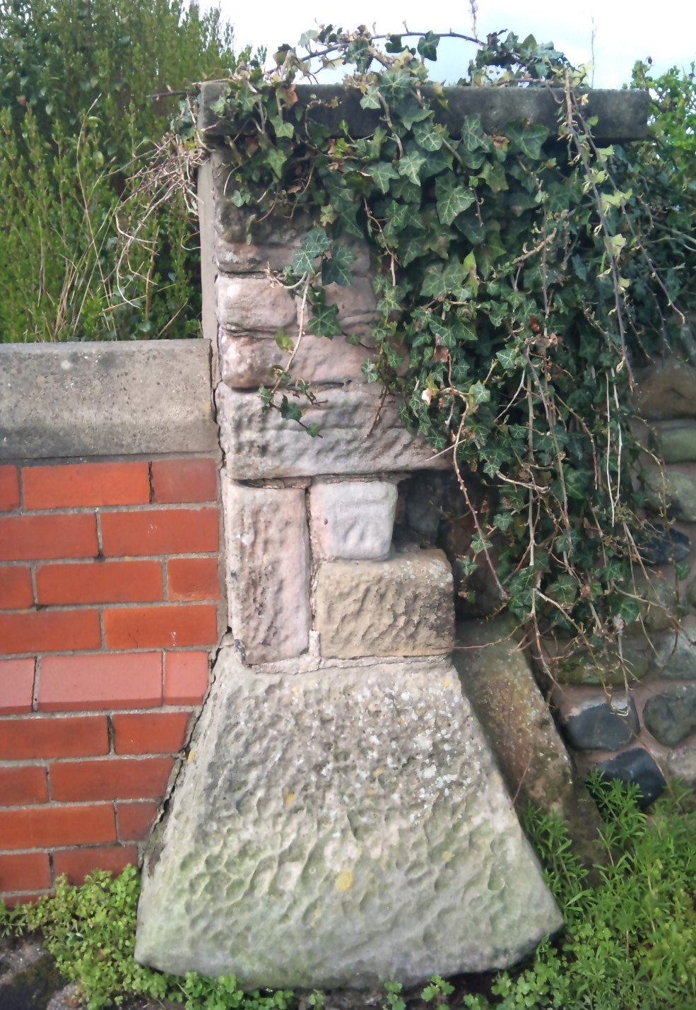

1. The Boundary Stone
This boundary stone, number 10, indicates the Gunnery Rifle Range from 1861 where soldiers practiced with their muskets. The Rifle Range stretched as far as the Golf Course where moving targets were situated. The road adjoining the Cemetery was originally named Cemetery Lane and was widened and developed in 1926 to form Beach Road. The area sur-rounding the Cemetery is where the Hutment Barracks and ammunition stores were built. Brickwork that was part of the Barracks can still be found on various streets nearby.

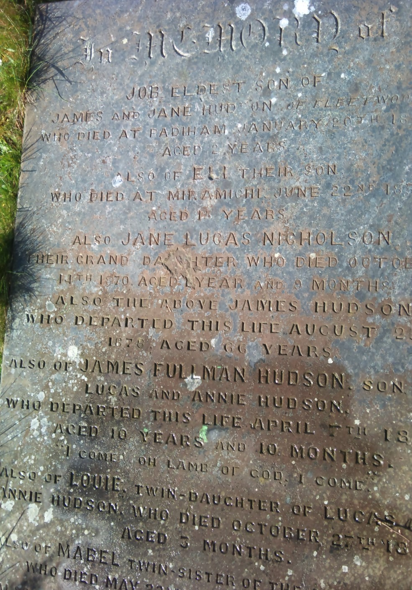

2. James Hudson
We believe that this vault was located in the Chapel that was originally here, there are 12 family members recorded buried within the vault. James Hudson was a Joiner originally from Padiham and he and his family travelled to Miramichi, Canada in the 1850’s as his son Eli died there. Miles Nicholson was Manager of Porters Shipping Company and James Hudson Nicholson was a Solicitor in St Peters Place.

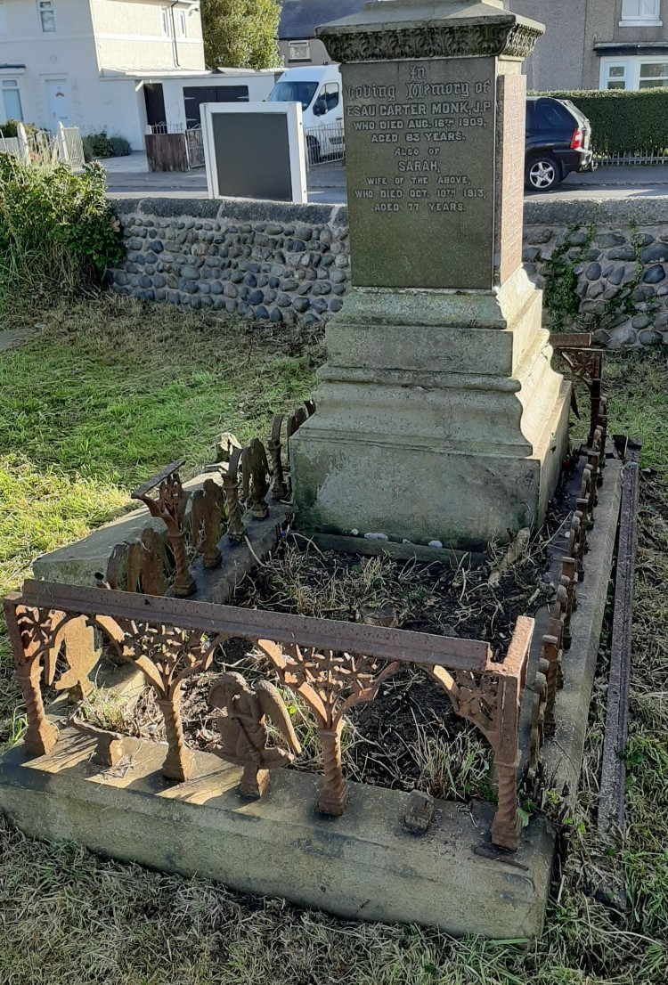
3. Esau Carter Monk
This is a large grave going over 3 plots for a family of entrepreneurs. Esau Carter Monks buried in 1851 the elder built the Adelphi Hotel in Blackpool, from the hotel he also ran an off licence and a postal business. His son Esau served as an Improvement Commissioner for the town of Fleetwood. The Commissioners were the local government in the early years. He also had a shop at 25 Church Street that he used for various businesses, namely Nailers, Ironmongers, Ironmongers & Lamp Manufacturers, Oil Merchant Dealers, Tin Plate & Gasfitter and finally Wine and Spirit Merchant. He also dispensed refreshments from the Mount Pavilion. The Monks families lived on Bold Street.
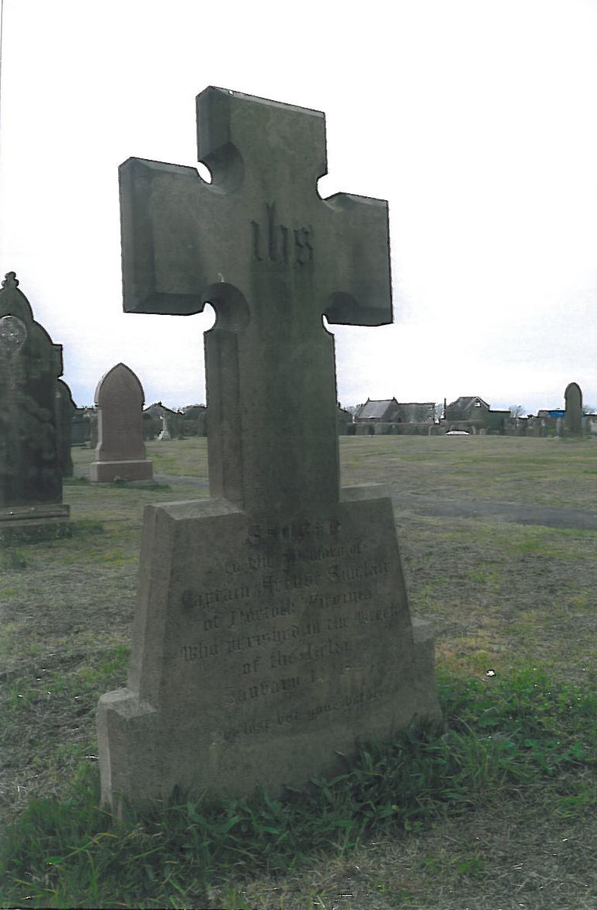
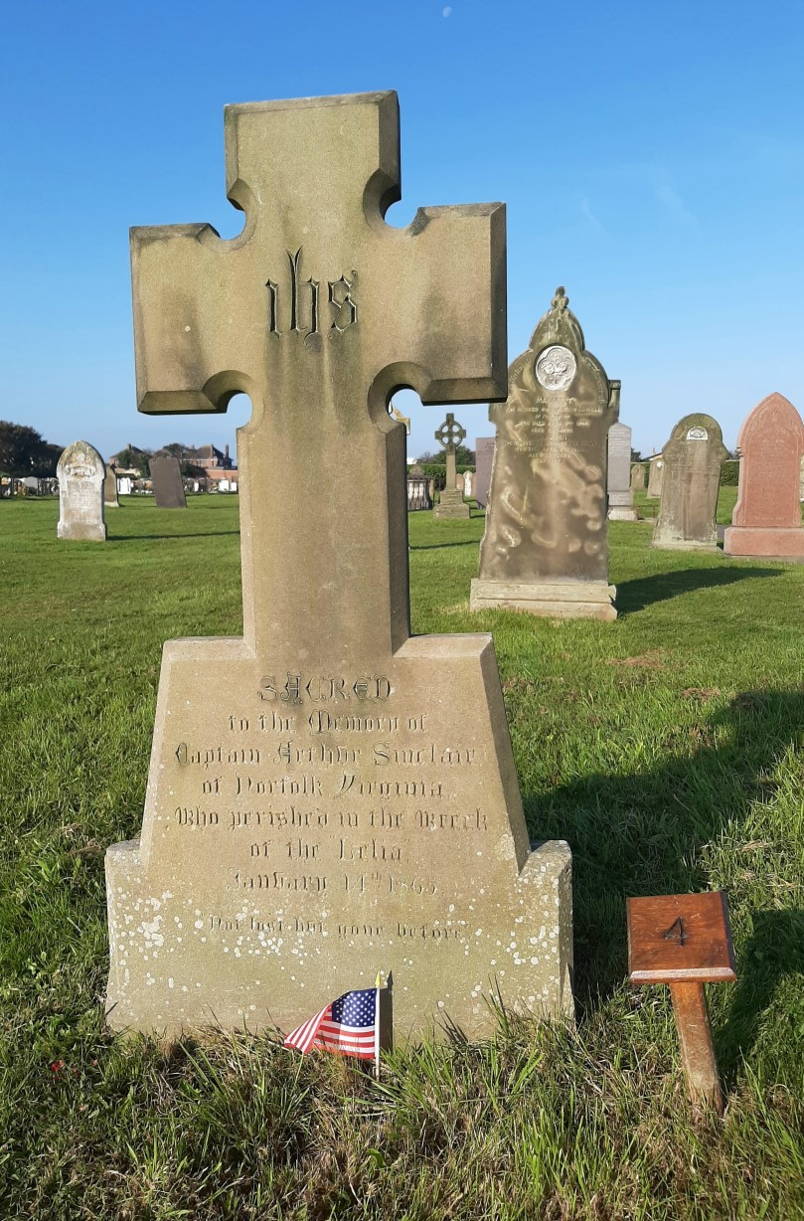

4. Arthur Sinclair
A commander in the Confederate Navy during the American Civil War, Arthur Sinclair was a resident of Norfolk, Virginia. He was lost from the vessel Leila a 252 Paddle Steamship in Liver-pool Bay on her maiden voyage and his body was washed up on the shore at Fleetwood his burial took place on 14th January 1865. An inquest was held at the Steamer Hotel in June of 1865 and Fleetwood residents raised funds for his burial here.

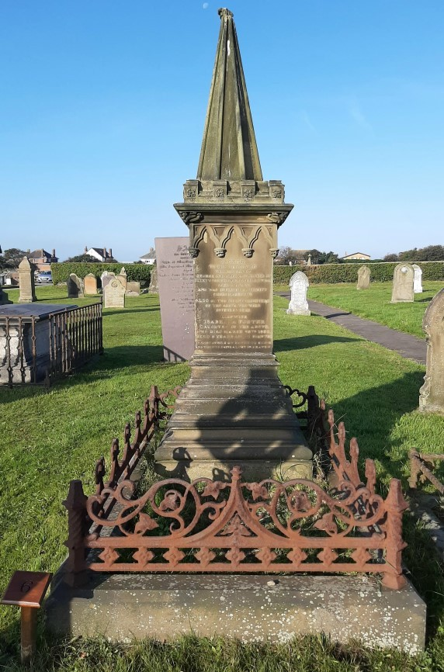
5. George Foster
A family vault with 3 family members is known to be buried here. George was the proprietor of the Crown Hotel on Dock Street, Fleetwood built be-tween 1841 and 1845, the building is now Pennine View and Grade II listed. George was a well-known businessman and his son Edward Shepherd Foster later followed in his footsteps and became the proprietor of the Crown Hotel.

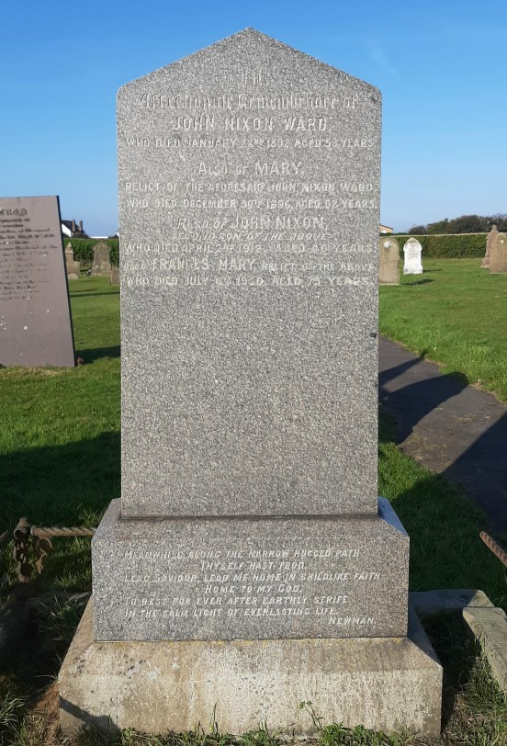
6. John Nixon Ward
Another prominent businessman, John Nixon Ward was a Ship owner and was part of the Norcross Ship Owners Company at Fleetwood. He died in January 1892 and later that year one of their ships, the SV Norcross was destroyed in a fire at Honfleur, France. His son John Nixon Ward Jnr was manager at the time and in June 1893 the company went into liquidation.

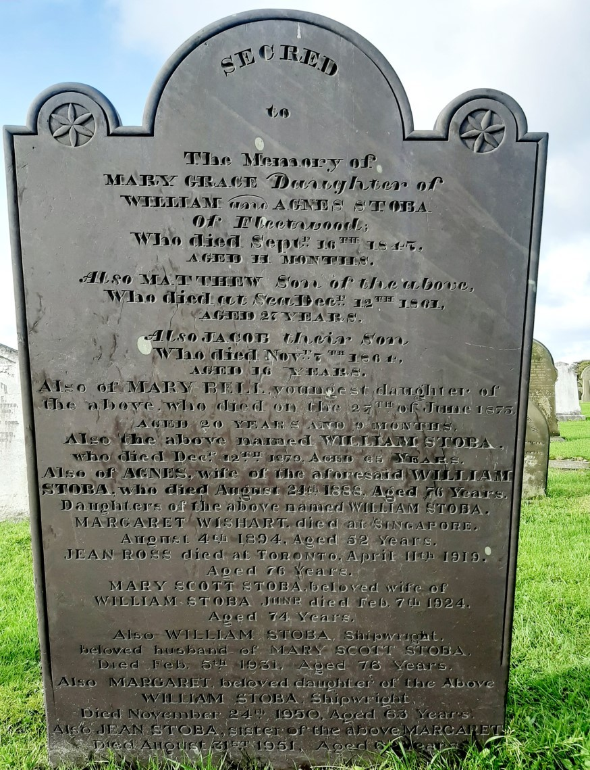
7. William Stoba
William was an exceptional boat de-signer. He was born in 1854 and began his apprenticeship aged 14 years at J Gibson & Son boat builders. He then went to Liver and Wildy and finally went to work for James Armour & Son in 1905. His boats became famous for their speed and for the quality of craftsmanship and many of them still survive today. William was buried 16 Dec 1879.

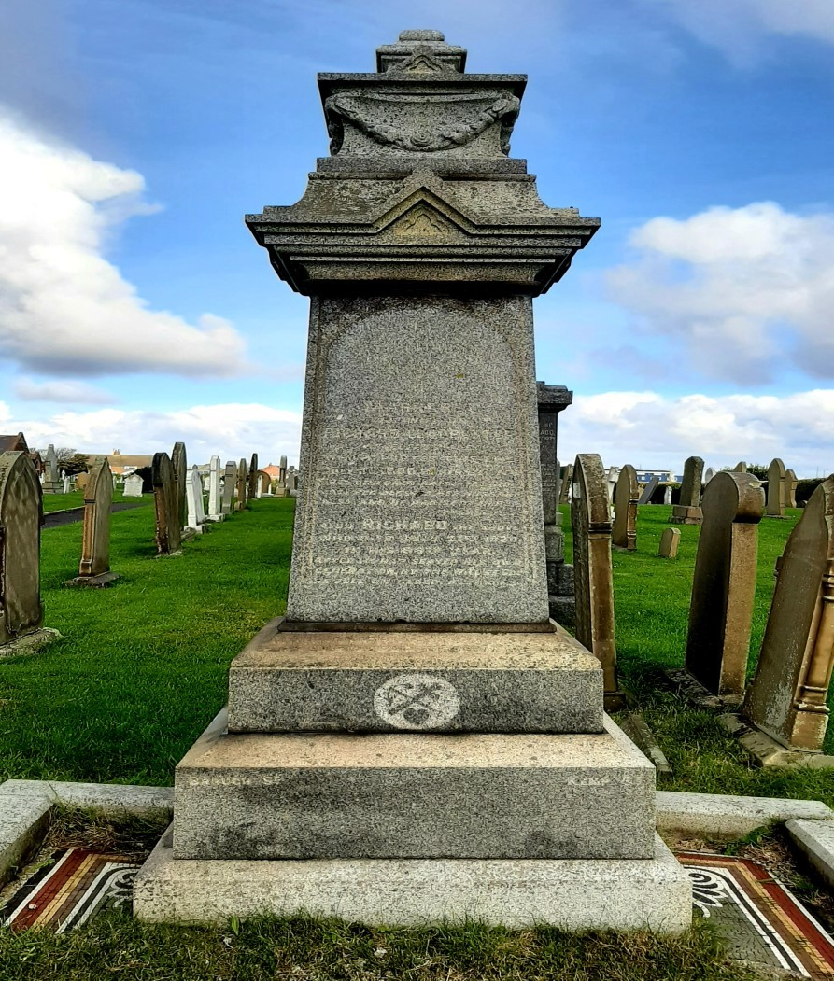
8. Richard Leadbetter
Richard died in 1920. He came to Fleetwood in the early years of the towns’ development, from Banks near Southport. A member of one of the first fishing families, Richard went on to become a prominent owner of many fishing smacks, including the co-ownership of the historic Harriet which can be seen in Fleetwood Museum. He also owned properties alongside the tram tracks on North Albert Street.

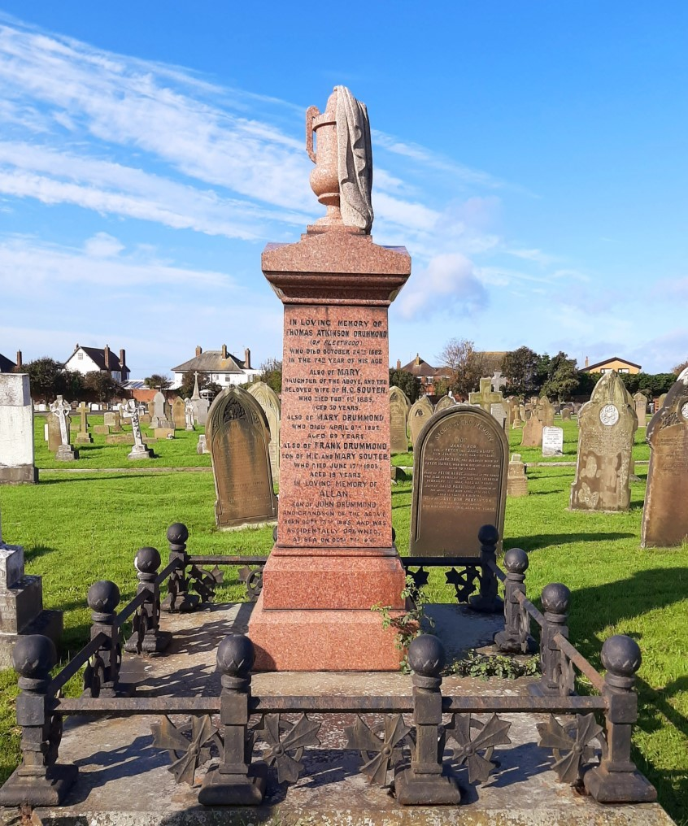

9. Thomas Atkinson Drummond
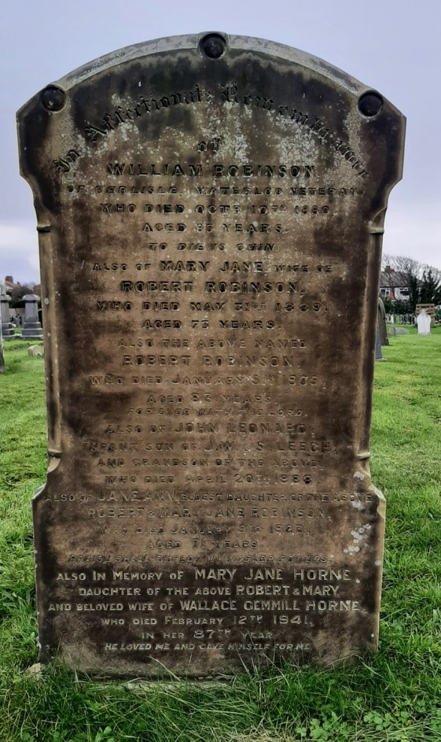
A master builder, Thomas came to Fleet-wood in 1836 with scores of bricklayers, plasterers, flaggers etc employed in making the town. He was responsible for designing and building prominent landmarks like the Whitworth Institute on Dock Street and the Congregational Church and schoolrooms, as well as hundreds of houses in the old part of town. He also carried out major work in Blackpool, Manchester and Preston. His funeral in 1882 caused many local businesses to close for the day and ships in dock flew flags at half-mast. Thomas buried within this family plot of 5 graves together on 27 October 1882.

10. William Robinson
He bravely fought in the battles of Switzerland, Antwerp and Waterloo in 1815 aged 18yrs he was buried with full military honours on 13 October 1880 aged 85 years the soldiers from the Hutman barracks in attendance.

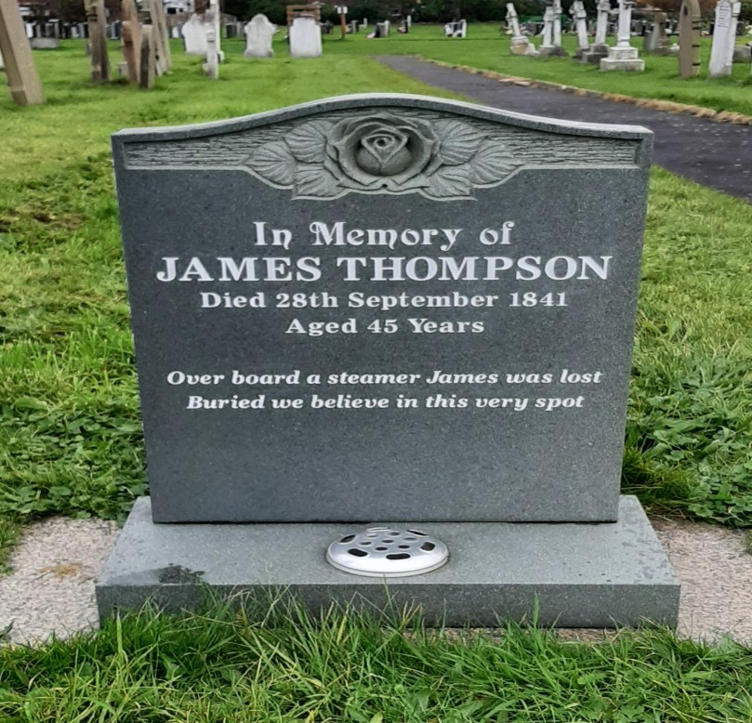
11. James Thompson
According to our records James Thompson was the first person to be buried in the Cemetery on the 28th September 1841 aged 45 years. He was found on the beach having fallen overboard from the Victoria Packet, one of the first steamers running between Fleetwood and Belfast. A native of Ireland. From kind sponsorship from co-op Funeralcare we had a memorial made in his remembrance.
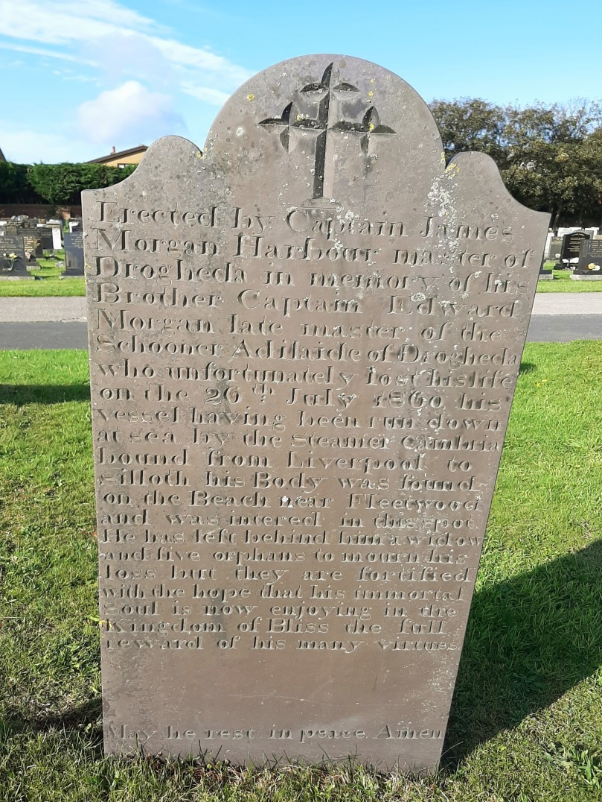

12. Captain Edward Morgan
This headstone was erected by Captain James Morgan, Harbour Master of Drogheda, in memory of his brother Edward who was the Master of the Schooner ‘Adelaide’ of Drogheda. The Adelaide was run down at sea by the Steamer Cambria bound from Liverpool to Silloth on 26 July 1860. His body was found on the beach near Fleetwood and was interred in this spot. He left behind a widow and five children.

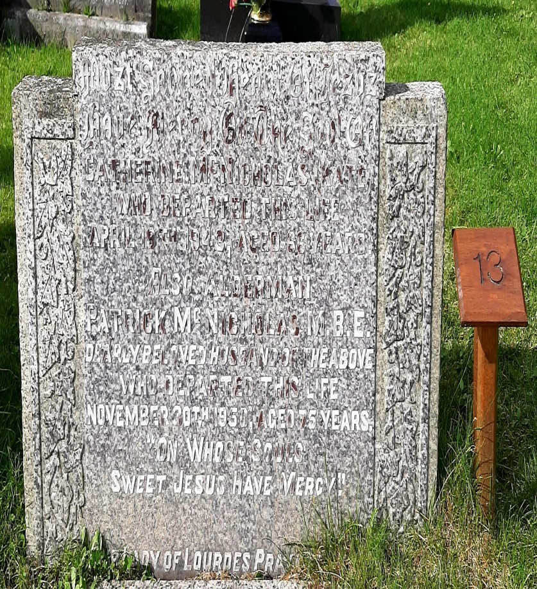

13. Patrick McNicholas

The first Catholic Mayor of Fleetwood, Alderman Patrick McNicolas M.B.E. ran the off license on Walmsley Street. His house had been used as the Catholic Chapel many years before until St Mary’s Church was built on Lord Street in 1866. Patrick died on 30th November 1950 aged 75 years.

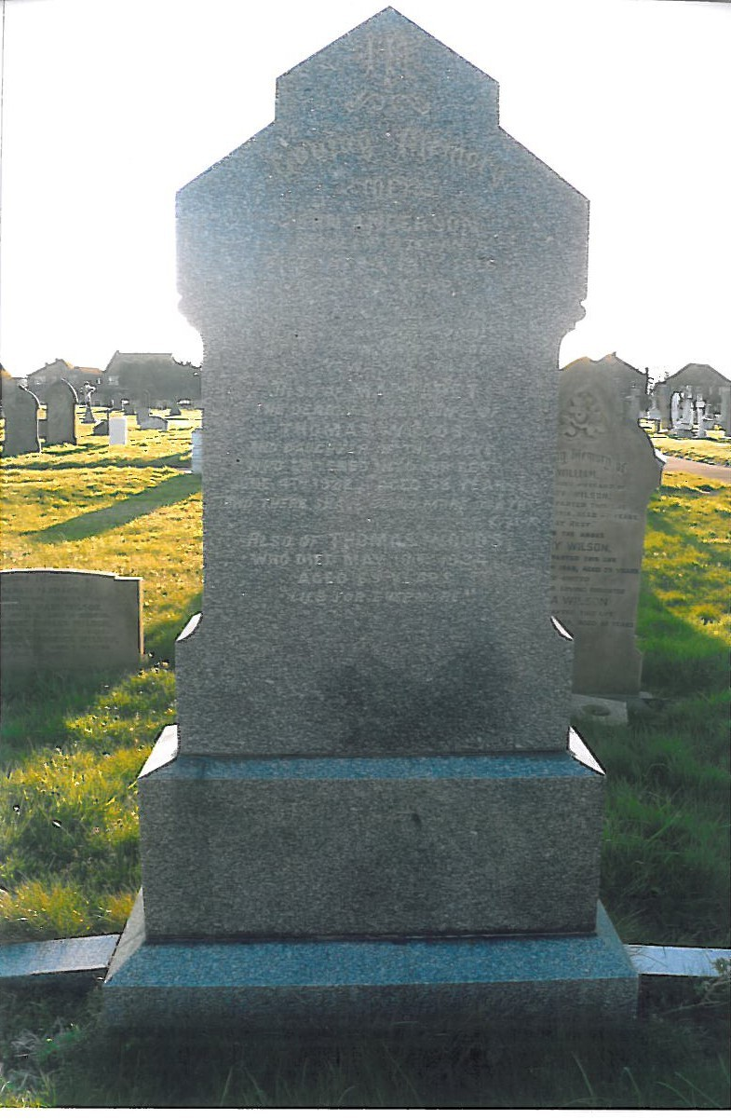
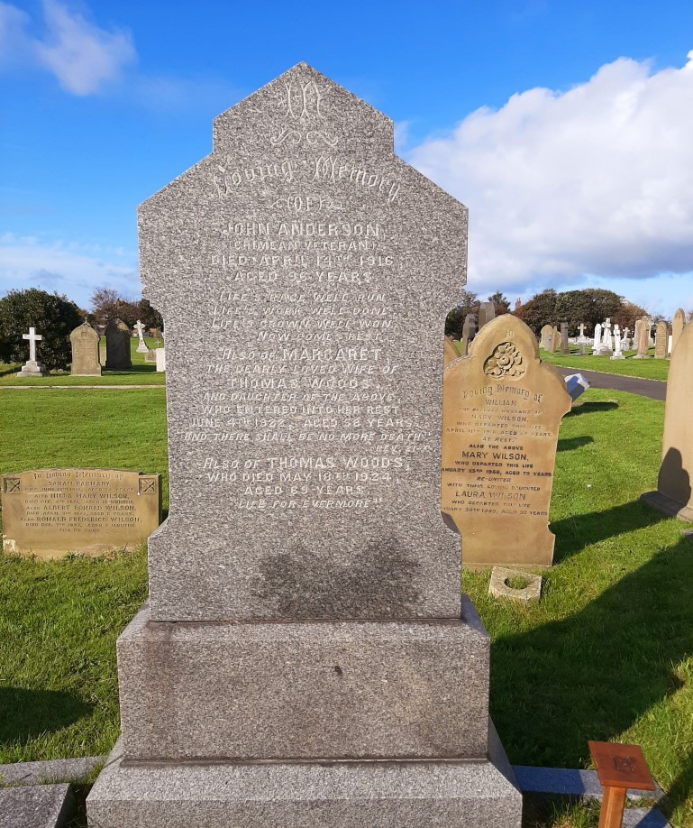
14. John Anderson
A well honoured Fleetwood Crimean War Veteran who died on 14th April 1916 aged 96 years. He fought in the Battle of Alma on 22nd September 1854 and in the Battle of Inkerman on 5th November 1854. Both of these battles were fought for the ultimate aim, the Siege of Sebastapol, the main Russian Naval Port. John fought in the final attacks on Sebastapol which took place in September 1855 and the war was finally over in 1856.

15. Philip Turner
This grave and garden area was uncovered by the Cemetery Grounds Team in 2007 when brambles were cleared. Philip was a very wealthy man, part of the Fleetwood Estate Company that purchased the lands, buildings, manorial rights and privileges of the late Sir P H Fleetwood. He owned a calico printing firm and a number of ships. His brother John married George Fosters’ daughter, Mary, the Fosters grave we have previously mentioned on the trail.
Philips father was James Aspinall Turner who was an MP for Manchester and was also a very wealthy and successful businessman. Philip died in 1888 whilst living at The Mount. He was a descendant of John Turner who had fought against the Old Pretender in 1715.
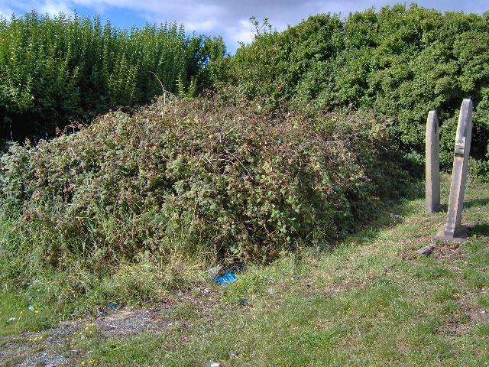
Before 2007

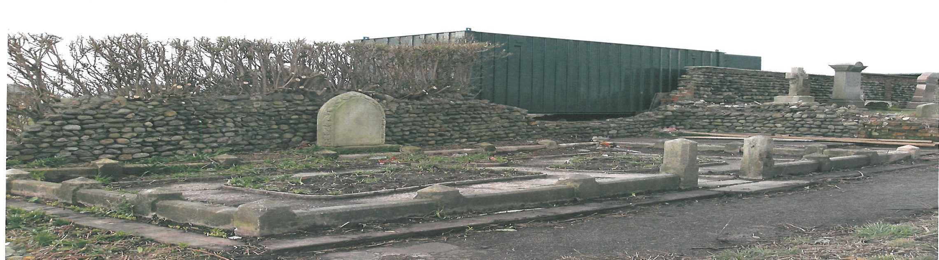
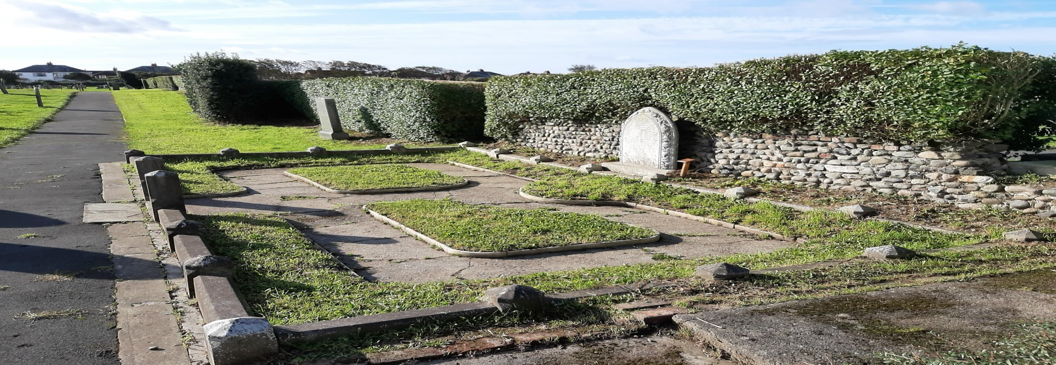
After 2007

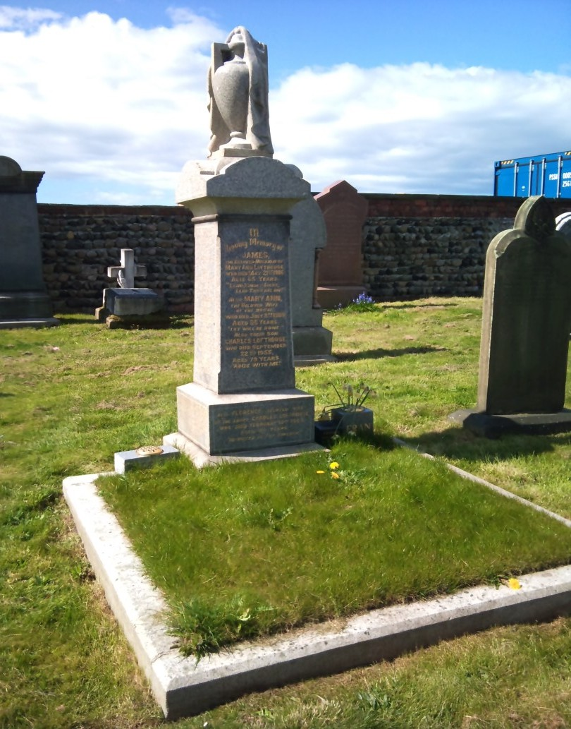
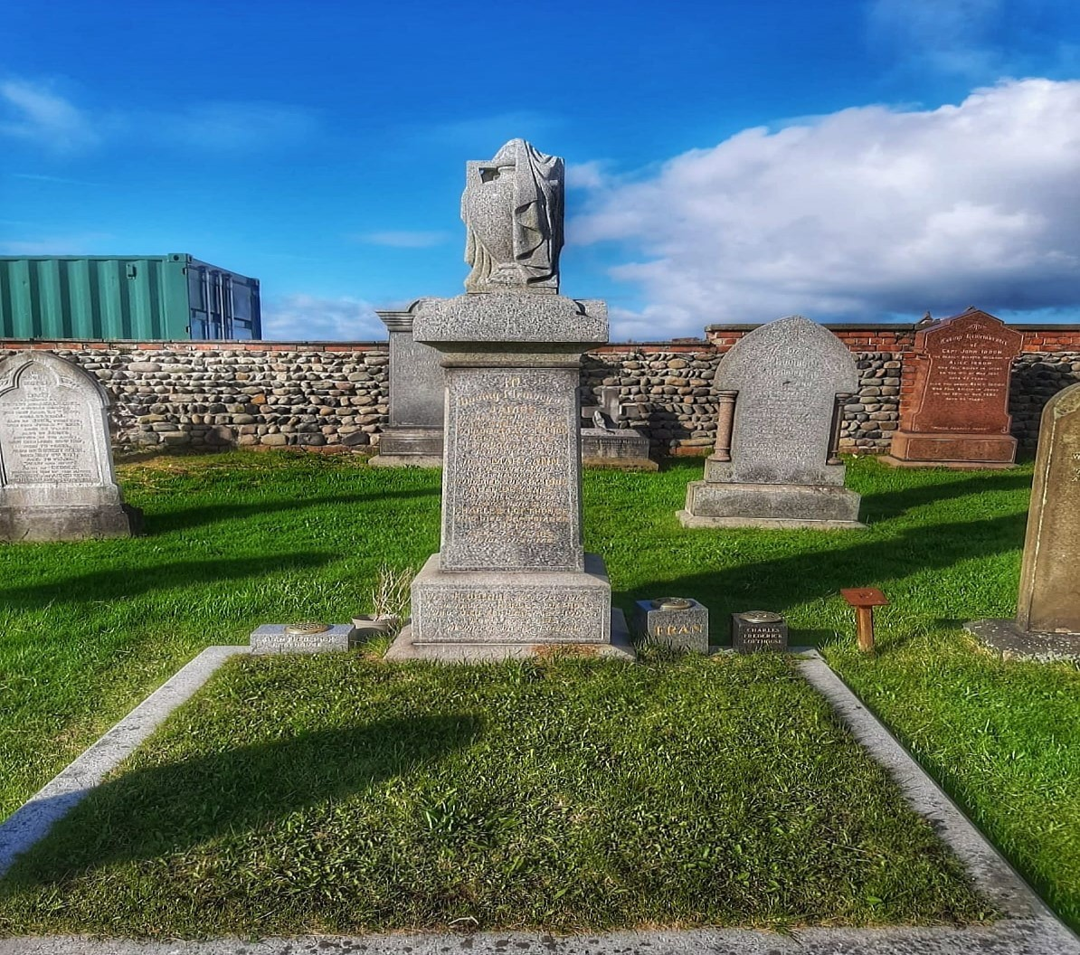
16. James Lofthouse
This memorial with a draped urn atop is the vault for the Lofthouse family. James was a chemist who established the famous Fisherman’s Friend product in 1865.
A lozenge that is now sold worldwide. The company has won the Queen’s Award to Industry for Export Achievement on three occasions. James passed away in 1906 aged 65 years.

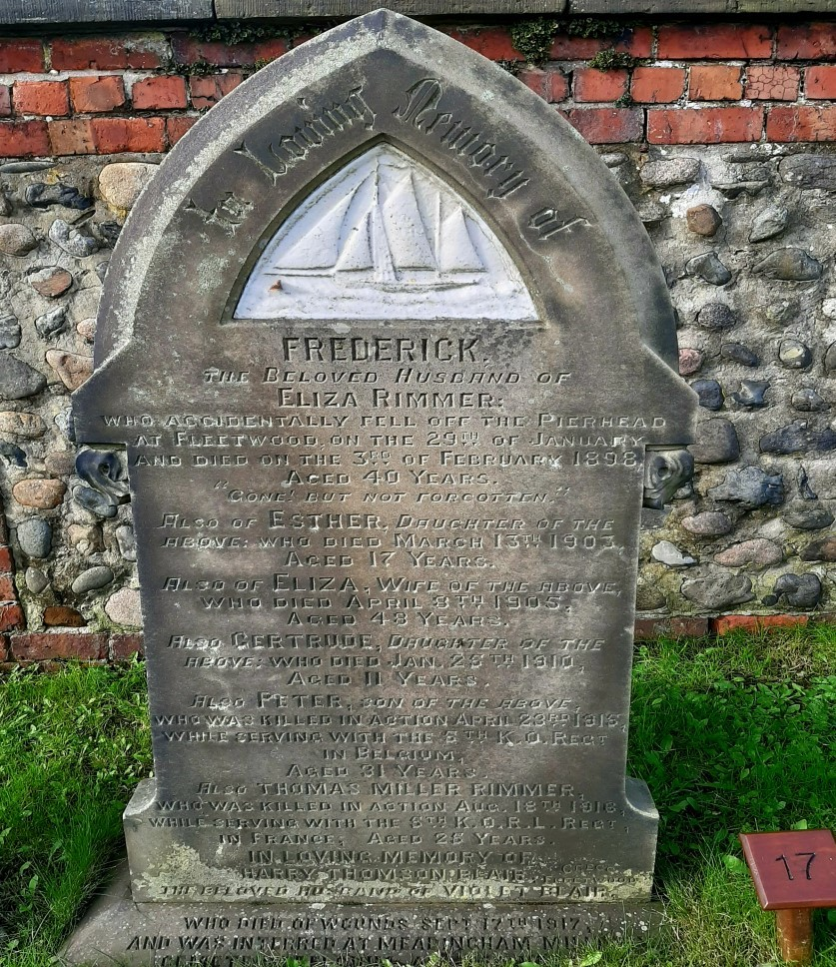

17. Frederick Rimmer
This sandstone memorial depicting a sailing smack in a white stone insert is the grave of Frederick Rimmer who died aged 40 years in 1898 after accidentally falling from the Pier Head. George was a Fisherman and his wife died only a few years later, leaving behind very young children.

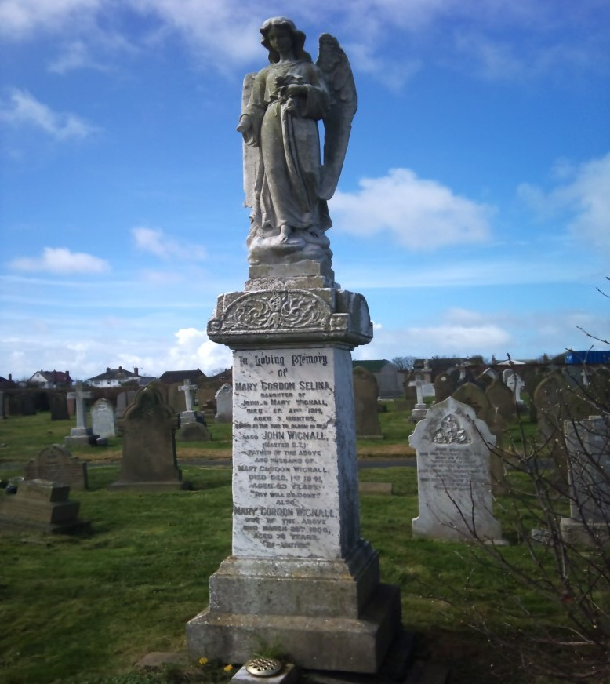
18. John Wignall
This angel headstone is one of the tallest memorials in the Cemetery. John’s daughter Mary was only 3 months old when she passed away in 1914.
John was a Master S.T. and owned a number of boats over the years, including the Sailing Trawler Sygnet and the S.T. Mary FD84 he was buried 4 December 1941 aged 63 years.

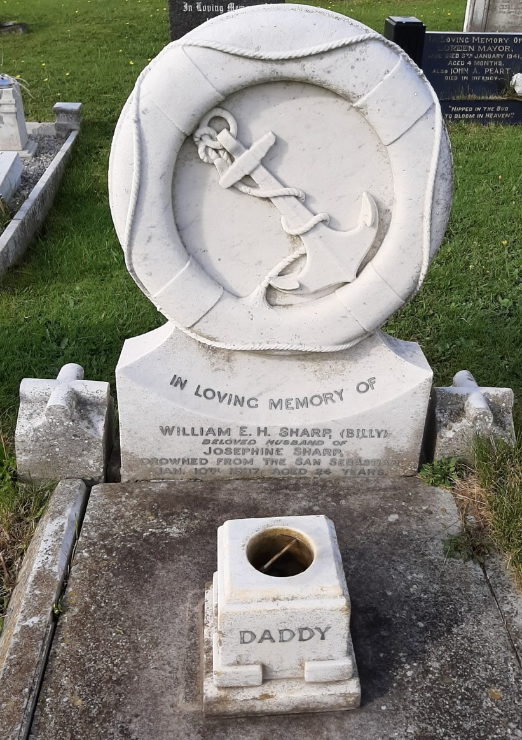

19. William Sharp
The grave of William ‘Billy’ Sharp, a young father aged 24 years who was lost from the trawler San Sebastian in 1937. The inscription ‘Daddy’ on the grave is a poignant reminder of the many tragic losses of our fishermen and the human impact of such losses.
This is the reason why we aim to preserve the history that is available in the cemetery for future generations.

20. War Graves
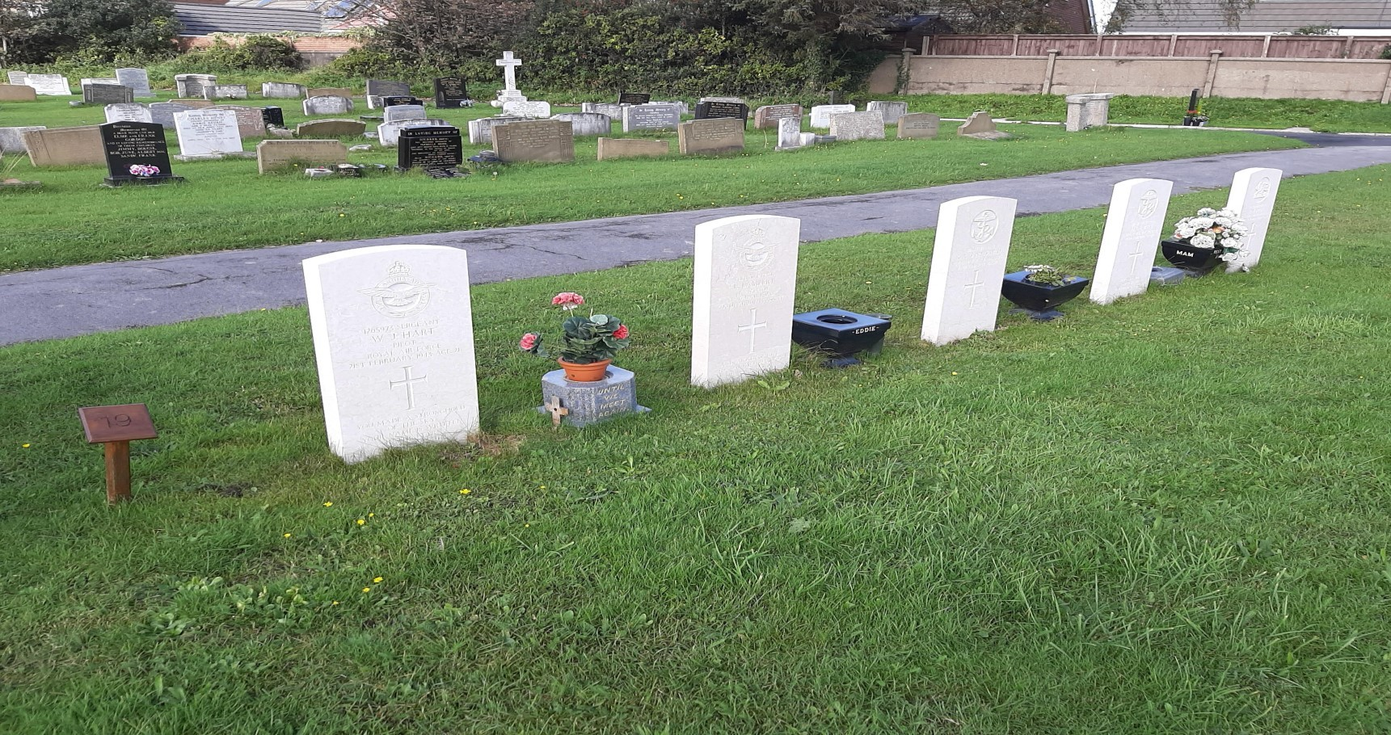
There are in total 91 memorials on the Commonwealth War Graves listing in memory of those lost during the wars. This area was dedicated to those that lost their lives but there are many memorials around the cemetery that are in memory of those that lost their loves through war or conflicts. They are remembered every year with a poppy cross by the British Legion. All the war memorials are maintained by the Commonwealth War Graves Commission who undertake regular inspections. A booklet is available from the office on request.

The information contained within this booklet has been put together by the Bereavement Services Office with the kind assistance of Dick Gillingham and staff at Fleetwood Museum.

Produced By Bereavement Services Office 2012 for 1st Fleetwood Cemetery Open Day. Photographs provided by Anita Fish.
Wyre Council, Breck Road, Poulton-le-Fylde, Lancashire, FY6 7PU Telephone 01253 891000.
Fifth Edition 2026

